**1.0 - Source Code Based Testing:**

**1.1 - Control Flow Based Testing:**

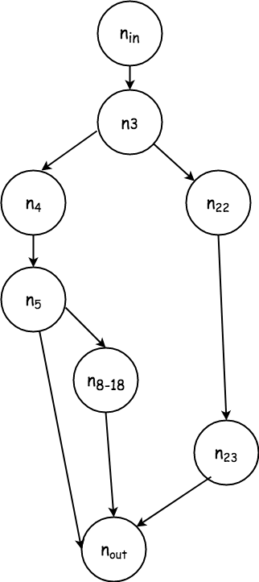

*Exhibit 1: Control Flow Diagram*

Only C2 path coverage is needed, since it subsumes all other control flow methods, and is attainable in this case with only 3 tests, which were already derived during specification based testing.

**1.1.1 Test Cases**

**LOOP COVERAGE**

|  |  |  |  |  |  |  |  |  |
| --- | --- | --- | --- | --- | --- | --- | --- | --- |
| **ID** |  | | **PARAMETERS** | |  |  | **Coverage** | |
| word_id | word | value | length | is_extension | bonuses_used | path | **%** |
| T_0_0 | 1 | “cat” | 20 | 1 | true | 0 | In, 3, 4, 5, 8-18, out | ⅓ = 33.3% |
| T_0_1 | -33 | “DOG” | 0 | 11 | false | 1 | In, 3, 4, 5, out | ⅔ = 66.6% |
| T_0_2 | 33 | null | 0 | 11 | false | 1 | In, 3, 22, 23, out | 3/3 = 100% |

**1.2 - Data Flow Based Testing**

**Skipped since path coverage subsumes all-use criteria**